

**Assignment 1**

**Cinema Management System**

**Submitted By:**

Muhammad SUBHAN MIR

SP25-BCS-106

**Submitted To:**

Shahid Bhatti

**Course Name:**

Object Oriented Programming

**COMSATS University Islamabad,**

**Lahore Campus**

**Cinema Management System**

# **SEAT CLASS**

## Booking/Cancelling Method

public boolean bookSeat(){

return this.isAvailable=false;

}

public boolean cancelBooking(){

return this.isAvailable=true;

}

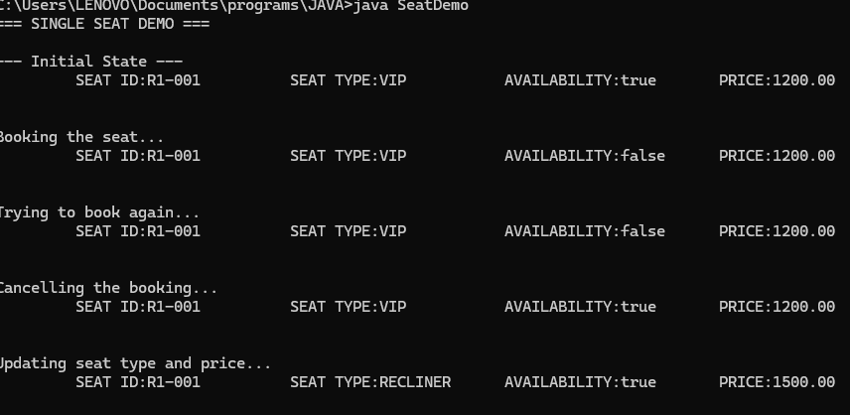

# SCREEN CLASS

## Layout Display Method

///====DISPLAY===///

public void displaylayout(){

for(int i=0;i<seats.length;i++){

for(int j=0;j<seats[i].length;j++){

System.out.print("[ "+seats[i][j].getseatID() +seats[i][j].getisAvailable()+"]");

}

System.out.println();

}

System.out.println("Total : "+gettotalseatcount()+", Available : "+getAvailableSeatCount());

}

}

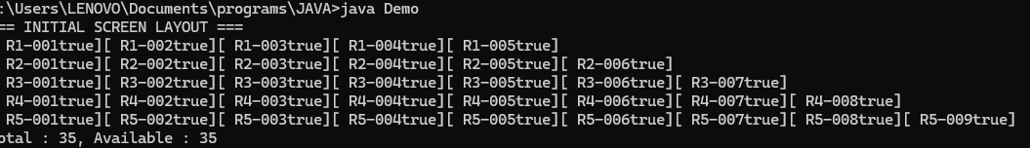

## Booking Method

public boolean booked(int r,int s){

r--;

s--;

if(seats[r][s].getisAvailable()){

seats[r][s].bookSeat();

return false;

}

else{

return true;

## Cancelling Method

//======CANCEL======////

public boolean cancel(int r,int s){

r--;

s--;

if(!seats[r][s].getisAvailable()){

seats[r][s].cancelBooking();

return true;

}

else{

return false;

}

}

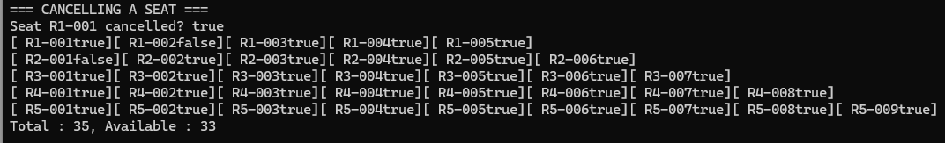

## Available Seats by Type

/====AVAILABLE SEAT TYPE===///

int getavailableseattype(Seattype t){

int availableSeat=0;

for(int i=0;i<seats.length;i++){

for(int j=0;j<seats[i].length;j++){

if(seats[i][j].getisAvailable() && seats[i][j].gettype()==t){

availableSeat++;

}

}

}

return availableSeat;

}



## First Available Seat By Type

//=====GET FIRST AVAILABLE====//

public Seat getFirstAvailableSeat(Seattype s){

for(int i=0;i<seats.length;i++){

for(int j=0;j<seats[i].length;j++){

if(seats[i][j].getisAvailable()&& seats[i][j].gettype()==s){

return seats[i][j];

}

} return null;}



## List Of Available Seat

//==== LIST AVAILABLE ===//

public Seat[] getListAvailableSeat(Seattype s) {

int count = 0;

for (int i=0;i<seats.length;i++) {

for (int j=0;j<seats[i].length;j++) {

if (seats[i][j].getisAvailable() && seats[i][j].gettype() == s) {

count++} }

Seat[] list = new Seat[count];

int index = 0;

for (int i=0;i<seats.length;i++) {

for (int j=0;j<seats[i].length;j++) {

if (seats[i][j].getisAvailable() && seats[i][j].gettype() == s) {

list[index]=seats[i] index++ } } return list

## GETTING SPECIFIC SEAT

//======= GET SEAT====///

public Seat getseat(int r,int s){

r--;

s--;

return seats[r][s];

}

